QDOK Access Management Process

Nov-2025

Contents
High Level Steps for access provisioning 2
Step 1: Access levels 3
Step 2: Training requirements 3
Step 3: Training documentation 3
Step 4: UACF Form Entry 3
Step 5: Upload UACF to Windchill Library 3
Step 6: QuickService Ticket Creation 3
Step 7: Ticket review by AMS 4
Step 8: Access provisioning on Windchill 4
Step 9: User Communication 4
Communication Templates 4
Step 10: UACF Approval 6
Proposed workflow for Access provisioning 7
References 8
User Instructions currently on BlueSpace: 9

High Level Steps for access provisioning
To obtain QDOK access, the following steps must be completed:
Please complete following steps for access to Global Windchill:

Step 1: Access levels
User requests for QDOK access through CDO/GMS or local document control team. GMS teams share information about different level of access and their definition.
Refer :QDOK Access Levels and Definitions table

Step 2: Training requirements
GMS team informs the user to complete training as per the requirements
GMS team shares the Role based training matrix with user.
“TRNG-TMX-00001489, QDOK Windchill System - Role Based Training Matrix”

Step 3: Training documentation
User documents the completion of the training and sends the certificate to GMS team team over email.
GMS Documentation team : CDO@freseniusmedicalcare.com
Local Documentation team

Step 4: UACF Form Entry
- GMS or local document control team fill out all sections in the correct User Account Control Form (UACF) as per the requested role.

Step 5: Upload UACF to Windchill Library
GMS or local document control team to upload the UACF to Windchill library (library details)
- Browse àLibraries à Foldersà Global Record Library àGlobal QMS à Computer Software Assurance àQDOK à Operational Document à User Account Records

Step 6: QuickService Ticket Creation
- Business users create the QuickService ticket with this UACF form as an attachment or references the QDOK UACF form.

Step 7: Ticket review by AMS
- Upon receiving the QuickService ticket, AMS team will review the UACF uploaded in QDOK system.

Step 8: Access provisioning on Windchill
- AMS team will process the access in system.

Step 9: User Communication
- AMS team will inform the user that required access is granted after resolving QuickService ticket.

Communication Templates
User creation communication template:
New Users
Subject: Your QDOK Account Has Been Created Based on Approved UACF
Content:
Your QDOK account has been successfully created based on the approved User Access Change Form (UACF) <mention UACF number>. Please find your login details below:
Login/Username <username>
Temporary Password <password>
Please note that your Windchill password is not synchronized with other systems (until further notice).
You can access QDOK using the link below:
https://plm.wc.gpdm-euc1.fmcglobal.net/Windchill/app/
Kindly update your password in GPDM QDOK Windchill by following the steps provided in the attached instructions document.
If you have any questions or issues, please contact the AMS Support Team at WindChill_AMS@freseniusmedicalcare.com or raise a ticket via the Quick Service Portal (https://qservice.intra.fmeone.com/servicedesk/customer/portals).
Thanks & Regards
Global Systems Support

Access Update communication template:
Subject: QDOK Access Updated Based on Approved UACF
Content:
Your QDOK access has been updated based on the approved User Access Change Form (UACF) <mention UACF number>. The requested roles and container permissions have now been applied to your account.
You can log in using your existing credentials at the link below:
https://plm.wc.gpdm-euc1.fmcglobal.net/Windchill/app/
If you face any access issues, please try logging out and back in to refresh your session. For any questions or further assistance, please contact the AMS Support Team at WindChill_AMS@freseniusmedicalcare.com or raise a ticket via the Quick Service Portal (https://qservice.intra.fmeone.com/servicedesk/customer/portals).
Thanks & Regards
Global Systems Support

Step 10: UACF Approval
This UACF goes through approval process on Windchill, AMS team approves the record once user is communicated.
List of AMS team members who will approve UACF documents in QDOK:
- Nikhil (nikhil.bhiste@freseniusmedicalcare.com)
- Spoorthy (spoorthy.hr1@freseniusmedicalcare.com)
- B M Goutam (ID yet to be created)
- Nitin (jain.nitin@freseniusmedicalcare.com)
- Gowthami (gowthami.konduri@freseniusmedicalcare.com)
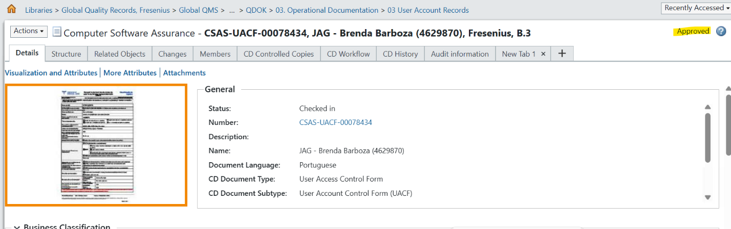
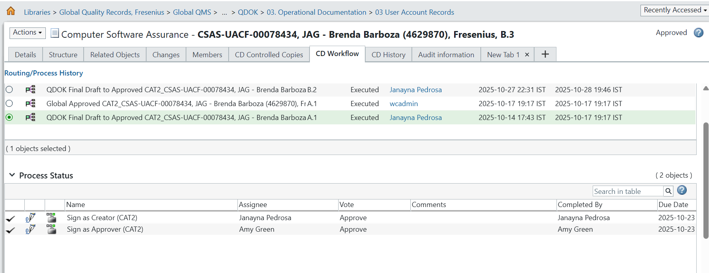
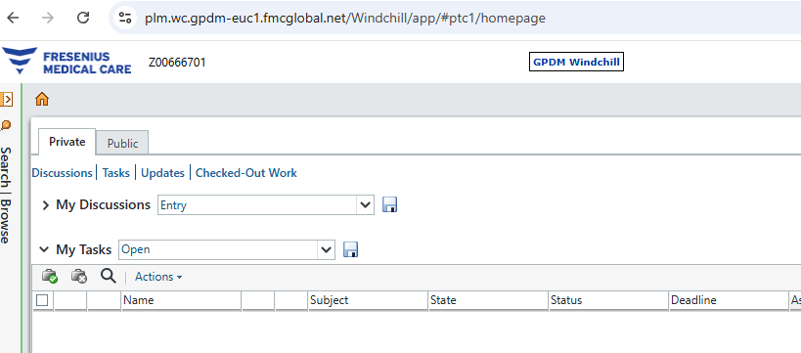

Proposed workflow for Access provisioning
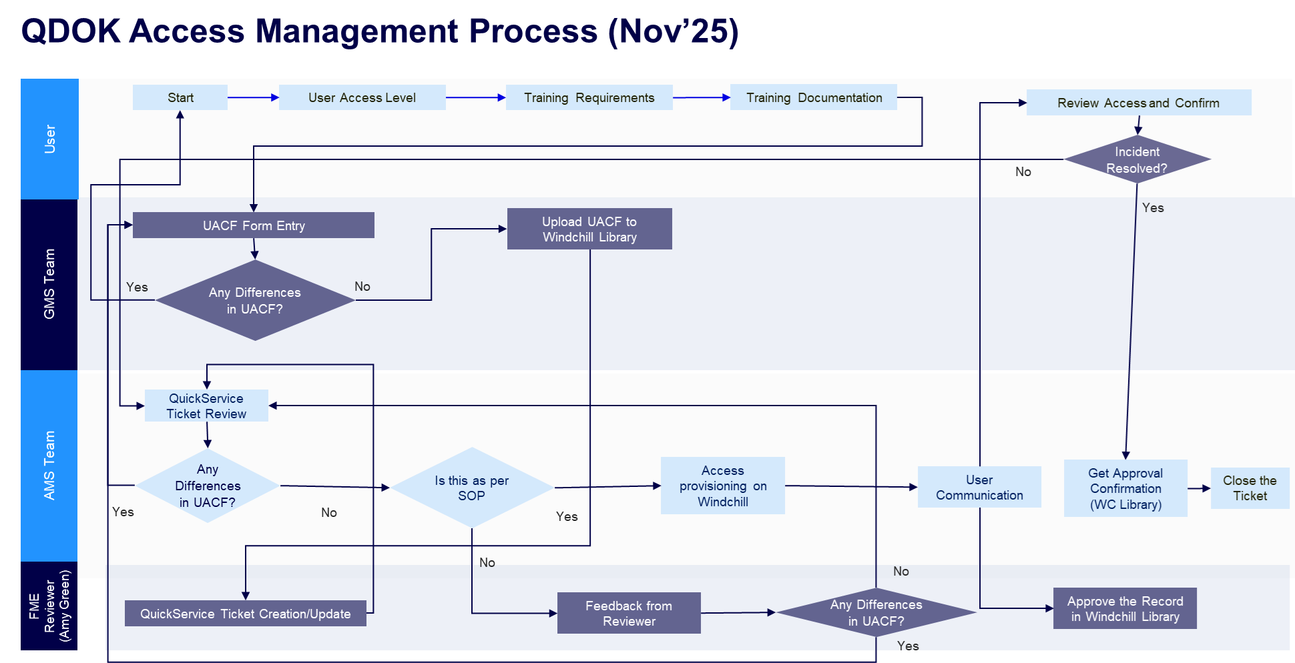

References
- QDOK Access Blue Space Runbook: Access to the GLOBAL & CQMS libraries in Global Windchill - Operational System, Quality & Regulatory - blue.space
- GMS Documentation team: CDO@freseniusmedicalcare.com
- Qservice : https://qservice.intra.fmeone.com/servicedesk/customer/user/login?destination=portals

User Instructions currently on BlueSpace:
To obtain QDOK access, the following steps must be completed:
- As a user, fill out the required documents:
  - UACF Form: This form captures the requestor’s account details and the specific access being requested.
  - Training Certificate: There are two types of training available:
    - Self-Directed Training
    - Instructor-Led Training
- Submit the completed documents to the GMS Documentation Team (CDO@freseniusmedicalcare.com) over email
- The GMS team will respond with the recorded access details.
- These recorded details must be reviewed and approved. QDOK access will only be granted after approval.
- Create a QService ticket referencing the recorded details to initiate the QDOK access provisioning.
- Any questions regarding UACF requests please reach out to Amy Green.
Note: Required document templates based on roles are available in the QDOK Access Blue Space Runbook.

